Machine Learning aided Stock Market Prediction

***​6th SEMESTER*** ***MINI PROJECT REPORT***

***FOR THE DEGREE OF***

**BACHELOR OF TECHNOLOGY**

***IN***

**INFORMATION TECHNOLOGY**



***by***

Mudit Rathore: ICM2015502

Ayushi Asthana: ITM2015004

Ishani Mishra: IWM2015008

Rakesh Reddy: IRM2015007

Anshula Gahrana: IIM2015005

|  |
| --- |
|  |
|

|  |
| --- |
|  |
|  |
|
|  |
|  |
|  |

***UNDER THE SUPERVISION OF***

Dr. Shirshu Varma

Assoc. Professor

**INDIAN INSTITUTE OF INFORMATION TECHNOLOGY,**

**ALLAHABAD**

**Candidate’s Declaration & Certificate**

We hereby declare that the work presented in this project report entitled “Machine Learning aided Stock Market Prediction”, submittedend-semester report of 6th Semester report of B.Tech. (IT) at Indian Institute of Information Technology, Allahabad, is an authenticated record of our original work carried out from Jan 2018 to Feb 2018 under the guidance of ​**Dr. Shirshu Varma​**. Due acknowledgements have been made in the text to all other material used. The project was done in full compliance with the requirements and constraints of the prescribed curriculum.

Date : 06th May 2018 Mudit Rathore (ICM2015502)

Place : Allahabad Ayushi Asthana (ITM2015004)

Ishani Mishra (IWM2015008)

Rakesh Reddy (IRM2015007)

Anshula Gahrana (IIM2015005)



**CERTIFICATE FROM SUPERVISOR**

I do hereby recommend that the mini project report prepared under my supervision by Mudit Rathore (ICM2015502), Ayushi Asthana (ITM2015004), Ishani Mishra (IWM2015008), Rakesh Reddy (IRM2015007) and Anshula Gahrana (IIM2015005) titled “Machine Learning aided Stock Market Prediction” be accepted in the partial fulfilment of the requirements of the completion of 6th semester of Bachelor of Technology in Information Technology for Examination.

Date: 06th May 2018 Dr. Shirshu Varma

Place: Allahabad IIIT-Allahabad

**Contents**

1. Abstract
2. Introduction
3. Motivation
4. Problem Definition
5. Literature Review
6. Stock Market Prediction using Artificial Neural Networks
7. Stock Market Prediction using Genetic Algorithm
8. Stock Market Prediction using Support Vector Machines
9. Comparison
10. Flow of work
11. Results
12. Conclusion and Future Work
13. References

Abstract

Stock market index forecasting is one of the most challenging tasks for one who wants to invest in stock market. In our study of machine learning algorithms to predict stock pricing index we have come across various techniques being used to predict the stock price index direction with various levels of accuracy in different time-frames.

This report presents a comparison between three such techniques namely Artificial Neural Networks[Adebiyi, Adewumi and Ayo, 2018], Genetic Algorithm[Naik, R. Lakshman, D. Ramesh, B. Manjula, and A. Govardhan. 2012], and Support Vector Machines[(ieeexplore.ieee.org, 2018)]. We want to draw a conclusion from previous studies on these algorithms and their working to find the technique best suited for further study and improved implementation.

# 

# Introduction

The stock market refers to the collection of markets and exchanges where the issuing and trading of equities (stocks of publicly held companies), bonds and other sorts of securities takes place, either through formal exchanges or over-the-counter markets. Also known as the equity market, the stock market is one of the most vital components of a free-market economy, as it provides companies with access to capital in exchange for giving investors a slice of ownership. A stock exchange is a place/organization through which stock trading can take place. Many large companies have their stocks listed on a stock exchange. This makes the stock more liquid and thus more attractive to many investors.

Apart from mathematicians and economists, financial institutions, traders, and speculators have created various proprietary models to try and predict the market movements, but rarely has anyone achieved consistently higher returns on investment. This can be owing to the simple fact - financial time series [Staff, 2018] is too complex and noisy to forecast. The factors having a positive impact on one set of stocks can be causing a fall in another set.

Traditionally, many prediction models have focused on linear statistical time series models such as ARIMA [Pai, P. and Lin, C. (2005)]. However, the variance underlying the movement of stocks and other assets makes linear techniques suboptimal, and non-linear models like ARCH tend to have lower predictive error[J. Zhang, 2009].

Stock prices tend to exhibit momentum [JEGADEESH, N. and TITMAN, S. (1993)]. Stocks that have recently been increasing continue to increase, and recently decreasing stocks continue to decrease. The type of trend implies some amount of predictability to future stock prices. Stock market also exhibit seasonal trends. Previous research conveys that trading strategies can exploit high winter returns and low summer returns to beat the market. [Rosillo, R., Giner, J. and De la Fuente, D. (2014)]

Such trends and involved complexity makes this problem a challenge for data scientists, the classification and prediction abilities of ML algorithms and the ability to identify relationships among seemingly random data is an important property which has led to development of comparatively very accurate algorithms for predicting stock price index.

Markets work on the emotions and reactions of buyers and sellers and therefore we can only predict, there always are outliers(black swan events [Taleb, 2010]) which affect market as a whole, and whose causes and effects cannot be predicted by any one domain specific study.

Motivation

Stock price prediction is one of the most widely studied and challenging problems, attracting researchers from many fields including economics, history, finance, mathematics, and computer science. The volatile nature of the stock market makes it difficult to apply simple time-series or regression techniques. Financial institutions and traders have created various proprietary models to try and beat the market for themselves or their clients, but rarely has anyone achieved consistently higher-than-average returns on investment.

Nevertheless, the challenge of stock forecasting is still appealing because an improvement of just a few percentage points can increase profit by millions of dollars for these institutions.

# Problem Definition

We are analysing three techniques used for Stock Index Prediction and draw a conclusion on the performance of each technique in varied market environments.

These techniques being - Artificial Neural Networks [Birgul Egeli, 2003], Genetic Algorithm [Naik, R. Lakshman, D. Ramesh, B. Manjula, and A. Govardhan. 2012], Support Vector Machine [(ieeexplore.ieee.org, 2018)].

These machine learning/optimization techniques along with their effect or reaction to the different time frames is studied and a suitable technique for our application is chosen for further study.

The stock market is dependent on multiple factors and thus the prediction of prices and regression is a problem involving many variables. Here we try to use the volatility and momentum information of different time-frames and try to draw a relation between them which will be the basis of our prediction.

# Literature Review

Most research with machine learning forecasting has focused on Artificial Neural Networks (ANN) [G. F. Bjoern Krollner, Bruce Vanstone, April 2010]. ANNs have a series of interconnected nodes that simulate individual neurons, and are organized into different layers based on function (input layer, processing layer, output layer, etc.). The ANN assigns weights to connections, and the output is calculated based on the inputs and the weights. As the machine trains, it notices patterns in the training data and reassigns the weights. Kar demonstrates that ANNs are quite accurate when the data does not have sudden variations [A. Kar, IIT Kanpur]. Patel and Yalamalle agree that ANNs can predict with accuracy slightly greater than 50%, but caution that since stock market data varies so greatly with time and nonlinearly, prediction is difficult even with advanced techniques like ANNs [S. R. Y. Mayankkumar B Patel, 2014]. Recent research in the field has used another technique known as Support Vector Machines in addition to or as an alternative to ANNs. Data mining approach using genetic algorithms (GA) is proposed to find good sets of rules which would have optimized the profit over a certain historical period.This study intends to find good sets of rules which would have made the most money over a certain historical period. This paper tends to mine reasonable trading rules using genetic algorithms for India Cements’ stock price index (ICSPI) future. Although there are an infinite number of possible rules by which we could trade, but only a few of them would have made us a profit if we had been following them. We have found trading rule which would yield the highest return over a certain time period using historical data.

Whereas ANNs are models that try to minimize classification error within the training data, SVMs may make classification errors within training data in order to minimize overall error across test data. A major advantage of SVMs is that it finds a global optimum, whereas neural networks may only find a local optimum. Using the SVM model for prediction, Kim was able to predict test data outputs with up to 57% accuracy, significantly above the 50% threshold [K. Jae Kim, 2003]. Shah conducted a survey study on stock prediction using various machine learning models, and found that the best results were achieved with SVM[V.H.Shah, 2007]. His prediction rate of 60% agrees with Kim’s conclusion. Since most recent research has incorporated SVMs, this is the technique we use in our analysis.

# Stock Market Predictions using Artificial Neural Networks

Artificial Neural Network has been used to predict the adjusted closing price of stocks. Feed forward neural network has been used for the prediction purposes.

We may not always be able to find patterns in inputs and outputs due to complex relationships between them, like in stock markets, many known and unknown factors affect the stock price. We cannot find significant mathematical relations between the factors and the price. There is growing need to solve highly nonlinear, time-variant problems as stock markets are nonlinear with uncertain behaviour that changes with time.[R. Fuller, 1995][E. Khan, 2000.]

ANN has the ability to discover relationships and hidden patterns in the input data set without a prior assumption of the knowledge of relation between the input and output data which can further be used for prediction purposes.

## How does it work?

Feed forward Neural Networks is unidirectional connection between the neurons that means the information can flow only in forward direction. Input is given to the first layer. With the help of intermediate hidden layers which are not interconnected, information is fed forward to the last layer that produces the output. Since information is constantly feeding forward from one layer to the next, it is called feed forward neural network.

For finding maxima or minima of a function, movement is done along the negative slope of the function which is what the backpropagation algorithm does.

Our aim is to minimize the error function. Thus we are repeatedly processing the training data set and comparing the ANN output with the actual output. Weights of the connections between various nodes are modified and this process is continued till the error comes under threshold value.

## Methodology

The work flow for the general neural network design process has four primary steps:

a)Data collection and preparation

Data is divided into three subsets, namely, training set, validation set and testing set.   
Training set is used to compute the gradient and updating the network weights and biases. Validation set is used to monitor error. When the network begins to overfit the data, the error starts rising. Minimum error weights can be used for the prediction purposes.

b) Network Creation  
Network has been created with the decision about the inputs, number of layers, number of neurons in each layer, transfer function to be used, outputs etc.

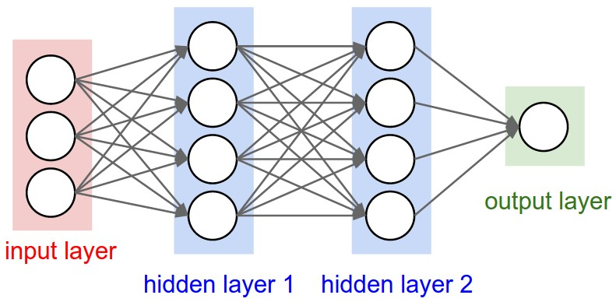  
 Fig. 1 – Structure of typical Neural Network  
  
c) Training the network  
The process of training a neural network involves altering the values of the weights and biases of the network to optimize network performance. The model is trained on 90-95% data and tested on 5%-10% data.  
d) Validating and using the network  
The network is validated using validation data to enhance its performance.

**Results**

*Case-I) Training data- 90% and prediction for 50 days:*

For training, Input - date, opening price of stock

Output- Adjusted price  
Predicted stock prices is compared to the actual stock prices. The average error was found to be 1.84%.

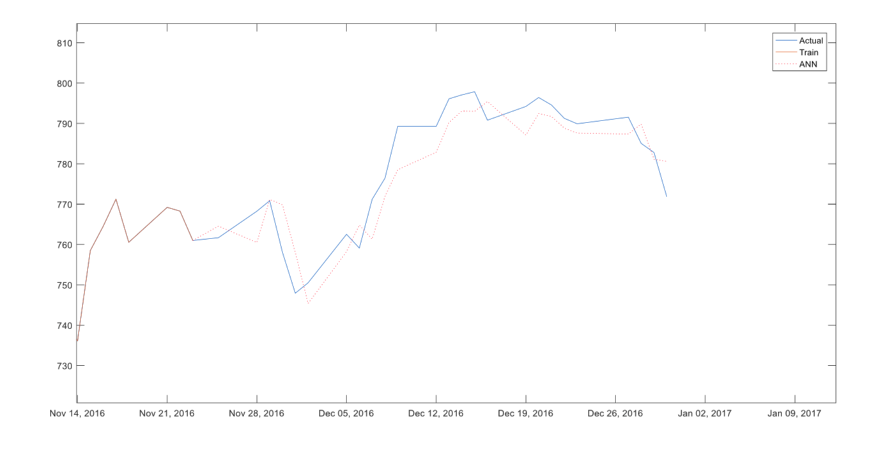

*Case-II) Training data- 95% and prediction for 25 days:*

In this case, the average error was found to be 0.71%.

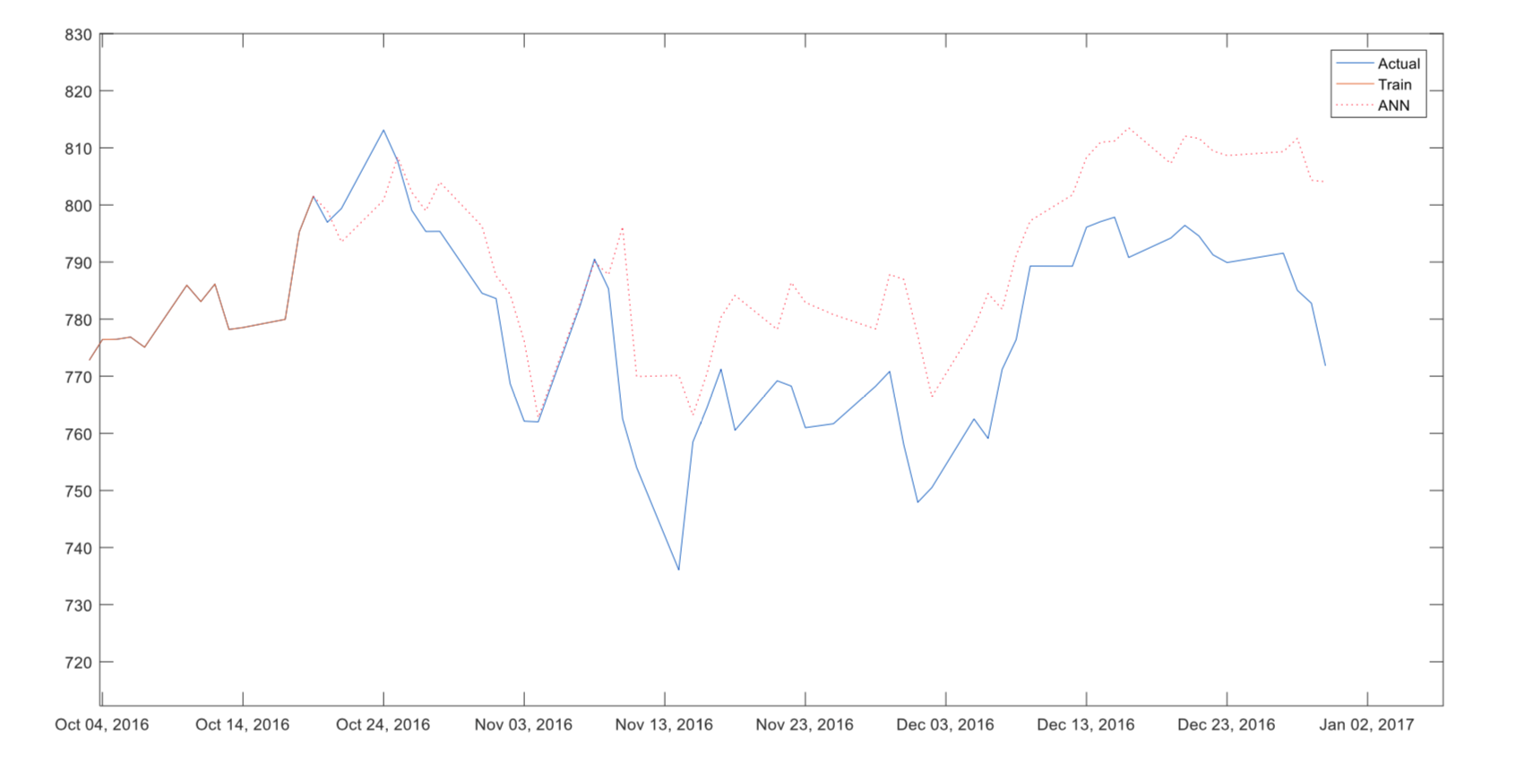

# Stock Market Predictions using Genetic Algorithm

First, we classify the direction of the price futures with several technical indicators using AI techniques. Second stage is mining the trading rules to determined conflict among the outputs of the first stage using evolve learning. In this paper they have found trading rule which yields highest return over a certain time period using historical data. These groundwork results [R. Lakshman Naik, D. Ramesh, B. Manjula, Dr. A. Govardhan, 2012] suggest that genetic algorithms are promising model and yield highest profit than other comparable models and buy and sell strategy.

**Technique used**

Data mining along with Genetic Algorithm

**How does it work?**

Data mining along with Genetic Algorithms is used to solve the knowledge acquisition problems that are evident in building and upholding rule-based applications for stock market. This paper tends to mine good sets of trading rules using genetic algorithms.

**Proposed Model**

Application of GA in the context of data mining is generally for the task of hypothesis testing and refinement, where the user poses some hypothesis and system first evaluates the hypothesis and seeks to refine it. Hypothesis refinement is achieved by “seeding” the system with the hypothesis and then allowing some or all parts of it to vary. The important aspect of the GA application is the encoding of the hypothesis and evaluation function for fitness.

GA operates in four stages: initialization, selection, crossover, mutation. The main idea of GA is to begin with a pool of solutions to a problem and try to find new generations of solutions which are better than older ones.

In the first stage, a pool of genetic structures are distributed randomly in the solution space is selected as the starting point of the search. Each structure is evaluated using a user-defined fitness function. The aim of the fitness function is to mathematically encode the performance of the structure.

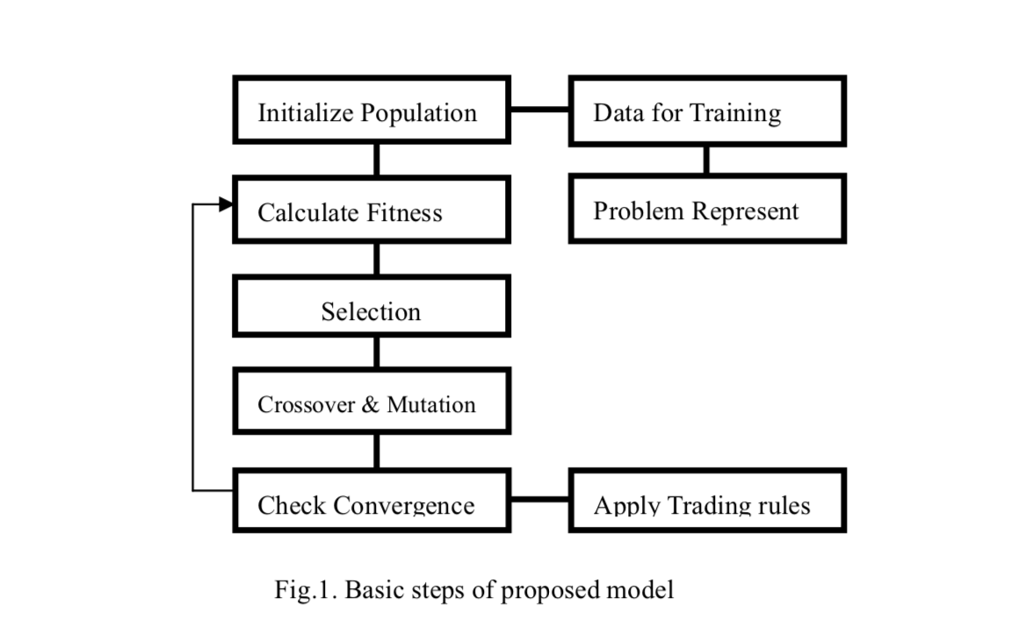

The convention of each entity is such that only the high scoring members will preserve and propagate their worthy characteristics from generations to generation and thereby help in continuing the search for an optimal solution. The entities with high performance may be chosen for replication several times whereas poor-performing structures may not be chosen at all.

Crossover causes to form a new offspring between two randomly selected ‘good parents'. Crossover operates by swapping corresponding segments of a string representation of the parents and extends the search for new solution. The crossover occurs only with some probability [R. Lakshman Naik, D. Ramesh, B. Manjula, Dr. A. Govardhan, 2012].

Stock Market Prediction using Support Vector Machines

Support Vector Machine (SVM) implements the structural risk minimization principle where many traditional neural network models had implemented the empirical risk minimization principle, SVM searches to minimize an upper bound of generalization error. In addition, the solution of SVM may be global optimum while other neural network models may tend to fall into a local optimal solution. Thus, over fitting is unlikely to occur with SVM.

**Technique Used**

The stock market prediction is done by the Support Vector Machine along with RBF kernel algorithm.

**RBF Kernel** This type of neural network is supervised algorithm and is a feed-forward network. It depends only on radial distance from a point. Like MLP, the RBF networks also have three different layers including input, output and hidden layer. Each hidden neuron represents a single radial basis function which has its centre and width (spread). RBF transforms the Nonlinearly separable classes into the linearly separable classes.

**How Does It Work ?**

SVM uses linear model to implement nonlinear class boundaries through some non-

linear mapping the input vectors *x* into the high-dimensional feature space. A linear model constructed in the new space can represent a nonlinear decision boundary in the original space. In the new space, an optimal separating hyperplane is constructed, maximum margin hyperplane. The maximum margin hyperplane gives the maximum

separation between the decision classes. The training examples that are closest to the

maximum margin hyperplane are called support vectors.

SVM constructs a linear model to implement non-linear class boundaries through transforming the inputs into the high-dimensional feature space.

For the non-linearly separable case, a high-dimensional version of maximum margin hyperplane is simply represented as follows:

$y = b +\sum{}α yi K(x(i), x):$

where the function K(x(i), x) is the kernel function.

Mukherjee et al. [S. Mukherjee, E. Osuna, F. Girosi, 1997] showed the applicability of SVM to time-series forecasting. Recently, Tay and Cao [F.E.H. Tay, L. Cao, 2001] examined the predictability of financial time-series including five time series data with SVMs and they showed that the upper bound (C) and the kernel parameter (K) play an important role in the performance of SVMs. Improper selection of these two parameters can cause the overfitting or the underfitting problems.

Comparison

Stock market prediction is regarded as a challenging task of financial time-series prediction. (Tsaihet al) [R. Tsaih, Y. Hsu, C.C. Laishani, 1998] integrated the rule-based technique and ANN to predict the direction of the S&P 500 stock index futures on a daily basis. But ANN often exhibits inconsistent and unpredictable performance on noisy data. However, back-propagation (BP) neural network, suffers from difficulty in selecting a large number of controlling parameters which include relevant input variables, hidden layer size, learning rate, momentum term.

ANNs are quite accurate when the data does not have sudden variations, but in stock market we encounter just the opposite of this, it is possible to find accuracy upto a certain limit with ANN but we need to incorporate other techniques in order to increase the accuracy of ANN in Stock Market prediction.

ANNs are models that try to minimize classification error within the training data, while SVMs may make classification errors within training data in order to minimize overall error across test data. A significant advantage of SVMs over ANN is that whilst ANNs can suffer from multiple local minima, the solution to an SVM is global and unique.

ANNs often *overfit* if training goes on too long, meaning that for any given pattern, an ANN might start to consider the noise as part of the pattern, therefore the predictions based on longer durations of data are not as accurate.

Unlike conventional statistical and neural network methods, the SVM approach does not attempt to control model complexity by keeping the number of features small.

GA gives us association rules for high profit, in itself, the prediction from GA isn’t of much use without prior knowledge of trading strategies and desirable conditions in the stock relations as the main idea of GA is to begin with a pool of solutions to a problem and try to find new generations of solutions which are better than older ones. Although the trading systems that have worked well in the past seem to have reasonable chance of doing well in the future, we need extensive validation process and it might change over a period of time, thus it is very difficult and not so productive to use GA for Stock Market Prediction without modification with some other techniques.

Support Vector Machine (SVM) implements the structural risk minimization principle where many traditional neural network models had implemented the empirical risk minimization principle, SVM searches to minimize an upper bound of generalization error.

Also with reference to "A comparison between regression, artificial neural networks and support vector machines for predicting stock market index." [25], we can support our claim that SVM model with RBF kernel model provided good prediction capabilities in comparison to the regression and ANN models.

In the study we conclude that SVM holds the most promising results and scope of development, and thus we used SVM to predict Stock Market Index for Standard & Poor's 500 (S&P 500) for the period of seven years from 2007 to 2014.

Flow of work

***Calculating volatility and momentum***

1. Define a window/time frame whose volatility will be calculated

2. Slide this window over the daily prices and calculate the average momentum and volatility of given window size

volatilityi = 100 * (pricei - pricei-1) /pricei-1

Window-meani = * ( volatilityi )

Momentum[i] = 1 if pricei > pricei-1

-1 if pricei < pricei-1

Window-momentumi =( momentumi

3. return the volatility and momentum

Results

The results of the above model are :

Maximum accuracy for 80-20 training testing ratio :: 0.702691924227318

Average accuracy for 80-20 training testing ratio :: 0.6549534339659668

Maximum accuracy for 70-30 training testing ratio :: 0.6988447749302882

Average accuracy for 70-30 training testing ratio ::0.6550484256865764

Maximum accuracy for 60-40 training testing ratio :: 0.7010468594217347

Average accuracy for 60-40 training testing ratio :: 0.652856903684824

**80-20 training testing ratio**

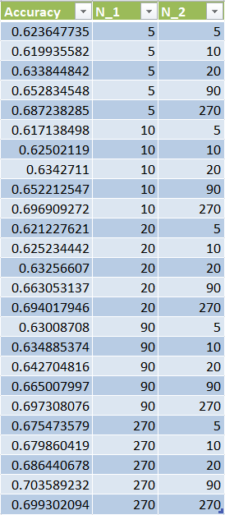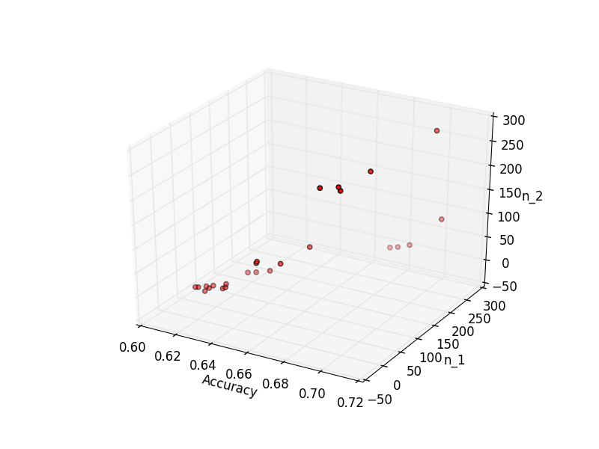

**60-40 training testing ratio**

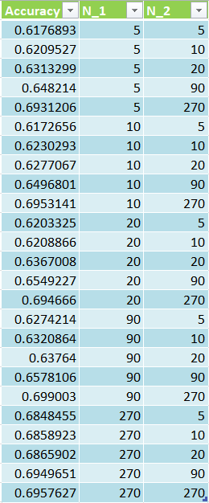 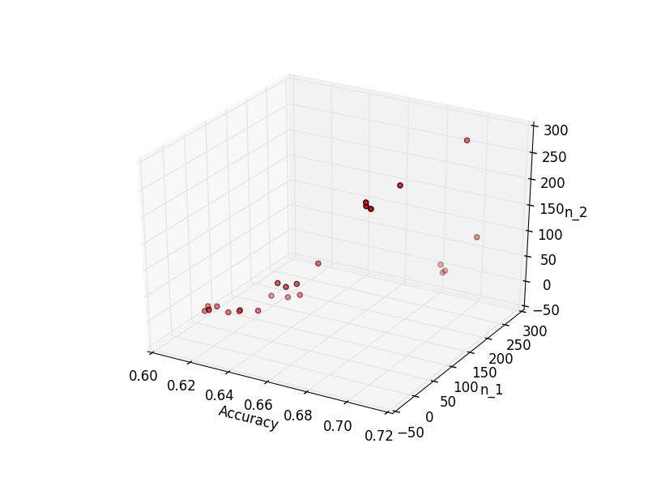

**70-30 training testing ratio**

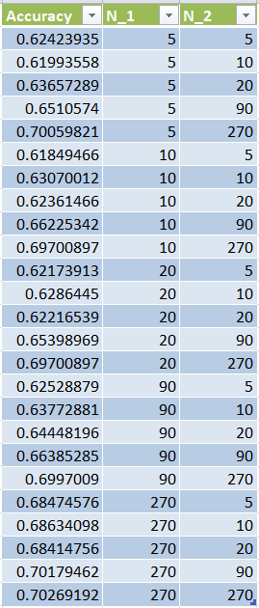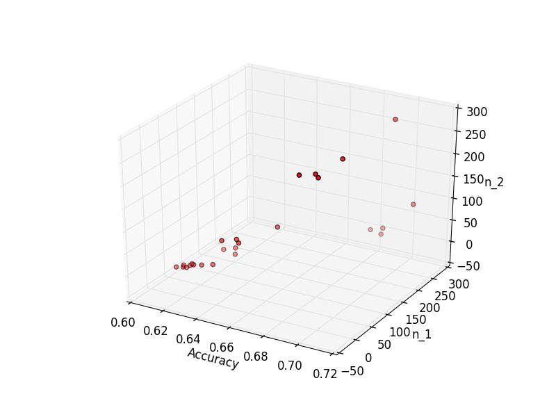

Conclusion and Future work

From the implementation of machine learning algorithm using RBF kernel for the prediction of stock price index we concluded that when it comes to predicting the stock market index for the next day or for next week it is simple random guessing only. This has very important implications, it reinforces the Efficient market hypothesis which states that it is impossible to “beat the market” because the stock market efficiency always causes existing share price to incorporate and reflect all relevant information.

We already know that stock market tends to exhibit momentum and the prediction of next day trends is as random as the coin flips. Prices reflect the information already available and the emotions of buyers and seller in the market, so the stock prices only change based on the new information that flows into the market. Our Model analyses the historical data and predicts the Stock Market Index based on the volatility, momentum and the time period chosen. We have used the data for Standard and Poor’s 500 for the period from 2007 to 2014 i.e. Seven Years and chosen 34 companies from the technical sector to compare against the index price.

We see that when the chosen period to predict is small then the period of Sector as well as the Index is of least importance as it is no less than simple guessing. Very short term trends, or long-term trends, are best for predicting the momentum of the next day, but fail at predicting prices for a substantial period in the future. The training period parameters start to gain importance as the prediction period becomes significantly larger. This implies that historical trends do not matter in the short term but are of greater importance in the longer run. If the training data reflects similar conditions to those in the testing data set, the predictive power of the model increases, however wrong datasets can just give unsatisfactory results.

The recent momentum of the stock and volatility are better than any other indicators as the most recent information and the current affairs always affect the stock prices, and those features then identified may lead to great return on investments.

The choice of the period must always be of great importance as it must be away from any outliers like natural calamities or sudden crashes in the economy. Other than that it is good to choose periods carefully for the Sector as well as the index.

We can further extend this study by looking at the intra-day trading in addition to the adjusted closing price. By observing intra-day trends, we can create more robust models that capitalize on sudden changes in momentum during intra-day trading. Individual stocks often have price swings that last only for a couple minutes, which an intra-day model can analyze, and then use to predict price direction in the next few seconds or minutes to earn profits.

# 

# References

1. A. Kar, “Stock prediction using artificial neural networks,” Dept. of Computer Science and Engineering, IIT Kanpur.
2. A. W. Lo, & A. C. MacKinlay, “Stock market prices do not follow random walks: Evidence from a simple specification test,” Review of financial studies, vol. 1, no. 1, pp. 41-66, 1988.
3. Adebiyi, A., Adewumi, A. and Ayo, C. (2018). Comparison of ARIMA and Artificial Neural Networks Models for Stock Price Prediction.
4. Birgul Egeli, Asst. "Stock market prediction using artificial neural networks." Decision Support Systems 22 (2003): 171-185.
5. Dr Shuxiang Xu, Prof Ming Zhang, 'Data Mining - An Adaptive, Neural Network Model for Financial Analysis'
6. E. Khan, “Neural fuzzy based intelligent systems and applications,” in Fusion of Neural Networks, Fuzzy Systems, and Genetic Algorithms Industrial Application, C. J. Lakhmi and N. M. Martin, Eds., The CRC Press International Series on Computational Intelligence, pp. 107–139, CRC Press, New York, NY, USA, 2000.
7. En.wikipedia.org. (2018) Great Depression. [online] Available at: https://en.wikipedia.org/wiki/Great_Depression [Accessed 20 Feb. 2018]
8. F.E.H. Tay, L. Cao, Application of support vector machines in financial time series forecasting, Omega 29 (2001) 309–317.
9. G. F. Bjoern Krollner, Bruce Vanstone, “Financial time series forecasting with machine learning techniques: A survey,” in European Symposium on Artificial Neural Networks: Computational and Machine Learning, Bruges, Belgium, April 2010.
10. Hu, Zhen, Jie Zhu, and Ken Tse. "Stocks market prediction using support vector machine." In Information Management, Innovation Management and Industrial Engineering (ICIII), 2013 6th International Conference on, vol. 2, pp. 115-118. IEEE, 2013.
11. Ieeexplore.ieee.org. (2018). Stocks market prediction using Support Vector Machine - IEEE Conference Publication. [online] Available at: http://ieeexplore.ieee.org/xpls/icp.jsp?arnumber=6703096&tag=1 [Accessed 20 Feb. 2018].
12. I.H. Witten, E. Frank, Data Mining: Practical Machine Learning Tools and Techniques with Java Implementations, Morgan Kaufmann Publishers, San Francisco, CA, 2000.
13. JEGADEESH, N. and TITMAN, S. (1993), Returns to Buying Winners and Selling Losers: Implications for Stock Market Efficiency. The Journal of Finance, 48: 65–91.
14. J. Zhang, “Applying time series analysis builds stock price forecast model,” Modern Applied Science, vol. 3, no. 5, 2009.
15. K. Jae Kim, “Financial time series forecasting using support vector machines”, Neurocomputing, vol.55, 2003.
16. Naik, R. Lakshman, D. Ramesh, B. Manjula, and A. Govardhan. "Prediction of Stock Market Index Using Genetic Algorithm." Computer Engineering and Intelligent Systems 3, no. 7 (2012): 162-71.
17. Pai, P. and Lin, C. (2005). A hybrid ARIMA and support vector machines model in stock price forecasting. Omega, 33(6), pp.497-505.
18. R. Fuller, Neural Fuzzy System, Abo Akademic University, 1995.
19. R. Lakshman Naik, D. Ramesh1, B. Manjula, Dr. A. Govardhan. Department of Informatics, Kakatiya University, Warangal-506 009, Andhra Pradesh, India, Department of CSE, JNT University (H), Hyderabad-500 085, Andhra Pradesh, India, Computer Engineering and Intelligent Systems www.iiste.org ISSN 2222-1719 (Paper) ISSN 2222-2863 (Online) Vol 3, No.7, 2012
20. R. Tsaih, Y. Hsu, C.C. Lai, Forecasting S & P 500 stock index futures with a hybrid AI system, Decision Support Syst. 23 (2) (1998) 161–174.
21. Rosillo, R., Giner, J. and De la Fuente, D. (2014). Stock Market Simulation Using Support Vector Machines. Journal of Forecasting, 33(6), pp.488-500.
22. S & P Dow Jones indices PDF, March 31 2015.
23. S. Mukherjee, E. Osuna, F. Girosi, Nonlinear prediction of chaotic time series using support vector machines, in: Proceedings of the IEEE Workshop on Neural Networks for Signal Processing, Amelia Island, FL, 1997, pp. 511–520.
24. S. R. Y. Mayankkumar B Patel, “Stock prediction using artificial neural network,” International Journal of Innovative Research in Science, Engineering, and Technology, 2014.
25. Sheta, Alaa F., Sara Elsir M. Ahmed, and Hossam Faris. "A comparison between regression, artificial neural networks and support vector machines for predicting stock market index." Soft Computing 7 (2015): 8.
26. Staff, I. (2018). Time Series. [online] Investopedia. Available at: https://www.investopedia.com/terms/t/timeseries.asp [Accessed 20 Feb. 2018].
27. Sukhdev Singh Chouhan, Amit Sharma, Dr. Vinod Sharma Vijay singh Rathore, “S&P Nifty forecasting using machine learning techniques with ANN approach”.
28. Taleb, N. (2010). The Black Swan: Second Edition. [S.l.]: Random House Publishing Group.
29. V.H.Shah, “Machine learning techniques for stock price prediction,” pp.1–18,2007.
30. V.N. Vapnik, Statistical Learning Theory, Wiley, New York, 1998.
31. XIAO-YE WANG, ZHENG-OU WANG, 'stock market time series data mining based on regularized neural network and rough set', Proceedings of the First International Conference on Machine Learning and Cybernetics, Beijing, 4-5 November 2002
32. Zhen Hu , Jie Zhu , and Ken Tse, 'Stocks Market Prediction Using Support Vector Machine'. 2013 6th International Conference on Information Management, Innovation Management and Industrial Engine.